**.UNIT 2**

**Computer Architecture**

Picture 2.1

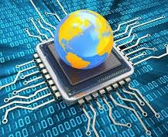

**Learning Outcomes**:

By the end of the lesson, the students are expected to be able to use appropriate English to:

▪ identify and describe kinds of computer

▪ read a computer advertisement

▪ identify parts of computer

▪ describe functions of parts of computer

▪ identify comparatives and superlatives

▪ identify phrases used for presentation

▪ perform a presentation using phrases explained

▪ compare and contrast computers and any other devices using comparative and superlatives

# 2.1. Reading a computer advertisement

**Exercise 1:** You are going to listen to an extract from an ICT class about **five** types of computer.

As you listen, identify the pictures (a-e) with words from the box.

Picture 2.2

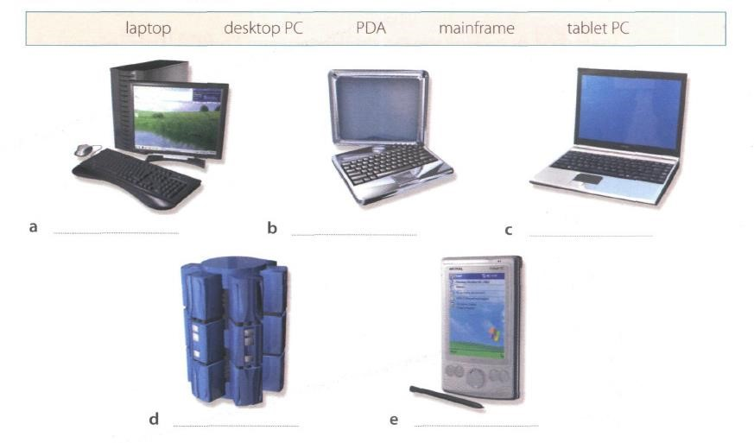

1. Desktop pc
2. Tablet pc
3. Laptop
4. Mainframe
5. pda

**Exercise 2**: Listen again and decide whether these sentences are true or false. Correct the false ones.

1. A mainframe computer is less powerful than a PC. (false)
2. A mainframe is used by large organizations that need to process enormous amounts of data. (true)
3. The most suitable computers for home use are desktop PC. (true)
4. A laptop is not portable. (false)
5. Laptops are not as powerful as desktop PCs. (true)
6. Using a stylus, you can write directly onto the screen of a tablet PC. (false)
7. A Personal Digital Assistant is small enough to fit into the palm of your hand. (true)
8. A PDA does not allow you to surf the Web. (false)

**Exercise 3**: Match these names to the different types of computer.

Picture 2.3

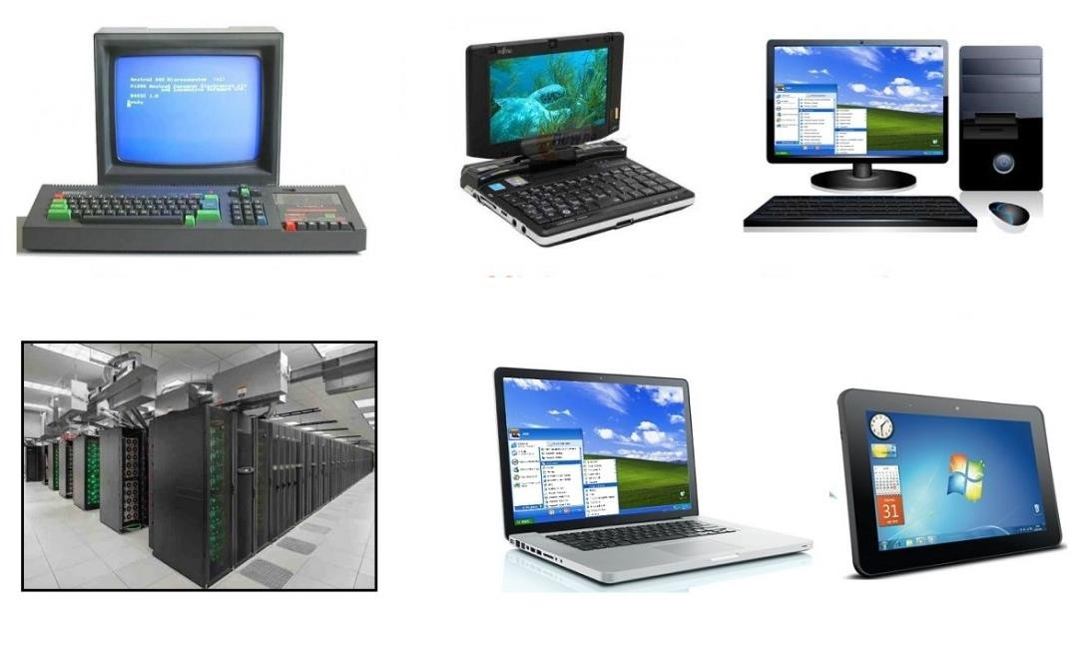

1. minicomputer 3. tablet 5. PC
2. laptop 4. microcomputer 6. supercomputer/mainframe
3. microcomputer
4. minicomputer
5. pc
6. mainframe
7. laptop
8. tablet

**Exercise 4**: Listen to Part 1 of the conversation between a shop assistant and a customer. Tick

(√) the correct answers to the questions below.

1. The customer wants a computer for......
   * writing  internet  games
   * graphics  video
2. A multimedia computer provides......
   * sound  telephone
   * graphics  video
   * games

**Exercise 5:** Listen to Part 2 of the conversation. In column A, tick hardware items named. In column B, tick the items the assistant recommends.

**A B Device A B Device**

*  multimedia computer   handheld b
*  multimedia notebook   printer b
*  subnotebook b   monitor
*  laptop   Modem b

**Exercise 6**: Study the text entitled ”How to Read a Computer Ad” and then answer the following questions.

* 1. What is the memory size of PC?

The pc contain memory with a capacity of 16gb

* 1. What storage devices are supplied?

The devices supplied 512 SSD & 2 TB Serial ATA hard drive (7200 r.p.m) storage.

* 1. What size is the display screen?

The size of the display screen is 42 inch with flat display screen

* 1. How fast is the processor?

operates at a clock speed of 3.6 GHz and has a front-side bus that operates at a speed of 800 MHz.

What is the capacity of the hard drive?

The capacity of the hard drive is 2 TB Serial ATA hard drive (7200 r.p.m)

* 1. Which operating system does it use?

The operating system used is Microsoft Windows 10 Professional

* 1. What multimedia features does the computer have?

The multimedia features that the computer has is 8 GB GDDR6 NVIDIA PCI-Express video graphic card and Integrated Dolby Atmos Stereo audio

**HOW TO READ A COMPUTER AD.**

1. Intel Core i7-9700K 9th Generation

(Coffee lake). Base Clock: 3.6 GHz,

Bus Speed: 800 MHz

1. Mini-tower chassis
2. 16 GB dual channel DDR4 SDRAM
3. 512 SSD & 2 TB Serial ATA hard drive (7200 r.p.m)
4. 8 GB GDDR6 NVIDIA PCI-Express video graphic card
5. Integrated Dolby Atmos Stereo audio
6. Corsair K95 RGB Platinum Keyboard Picture 2.4
7. 42” TFT flat panel 4K (3840 x 2160) monitor
8. Microsoft Windows 10 Professional

1. The main processing chip 4 A Solid-state drive with a 6 Electronics for controlling called a ‘core i7’ that was 512 gigabytes storage and the sound output that is

designed and a hard drive with a built into the main

manufactured by the intel capacity of two terabytes electronics of the Corporation. It operates at that uses a type of computer. a clock speed of three- connection interface 7 The K95 Platinum is a big point six gigahertz and has known as Serial ATA. It has keyboard. Dedicated a front-side bus that a serial data connection media controls and a USB operates at a speed of rather than the original pass-through, a metal eight hundred megahertz. parallel connection. It volume wheel, RGB

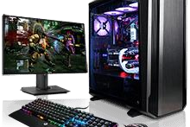

1. A small, tall and narrow rotates at a speed of seven lighting. It even comes style of case containing thousand, two hundred with an extra set of the computer system. revolutions per minute. textured keycaps for the 3 Synchronous dynamic 5 Electronics for driving the WASD keys.

random-access memory graphics output that has a 8 A forty-two inch, flat with a capacity of sixteen memory capacity of eight display screen made from gigabyte. It is a high gigabytes and uses a type thin film transistors with a bandwidth, double data of connection interface resolution of 3840 by rate memory. known as PCI-Express. 2160.

9 The operating system that is used to control the system.

*Oxford English for Information Technology (2011: 11)*

# 2.2. Describing functions of computer

We can describe the function of an item in a number of ways. Study these examples.

|  |  |
| --- | --- |
| **Using the present simple**   1. ROM *holds* instruction which are needed to start up the computer.     ***Used to-*infinitive, *Used for + -ing* form**   1. ROM is  *used* to *hold* instructions which are needed to start up the computer. | 1. ROM is *used for holding* instructionswhich are needed to start up the computer.     **Emphasizing the function**   1. *The function of ROM is* to hold instruction which are needed to start up the computer. |

**Exercise 7**: Match each item with its functions. Then describe the functions in three ways as the examples on the table above.

|  |  |  |
| --- | --- | --- |
| **Items** |  | **Functions** |
| 1. RAM (g) 2. processor (j) 3. mouse (a) 4. clock (i) 5. flash memory key (e) 6. monitor (c) 7. keyboard (b) 8. cache (h) 9. DVD-ROM drive (d) 10. ROM (f) | A.  B. C.  D.  E.  F. | controls the cursor  inputs data through keys like a typewriter displays the output from a computer on a screen  reads DVD-ROMs  reads and writes to electronic chips on a card  holds instructions which are needed to start up the computer |
|  | G. | holds data read or written to it by the processor |
|  | H. | provides extremely fast access for sections of a program and its data |
|  | I. | controls the timing of signals in the computer |
|  | J. | controls all the operations in a computer |

**Exercise 8**: With your partner, describe the functions of these items using the forms you have learned before.

1. Scanner: function is to scan or take a picture of the document, digitize the information and present it on the computer screen
2. Printer: a unit attached to a compute that produces text on paper (hard copy of a document); PERIPHERAL DEVICE
3. CPU: the "brains" of the computer. Processes data and controls the flow of data between the computer's other units; INTERNAL OPERATING UNIT
4. SSD: The function is for storage media that uses non-volatile (flash) memory to store and access data
5. hard disk driver : hard disk drives control the reading and writing of the hard disk that provides data storage
6. ports: The main function of the port is to transfer data from external or internal devices to the user's PC or laptop.
7. mainframe computer: Mainframe computers are mainly used to handle large organizational data for critical applications, such as big data processing, census, industrial and consumer statistics, to transaction processing.
8. Barcodes: barcode serves to store complete information about an item or product that has a barcode label.
9. swipe cards: plastic card such as a credit card or ID card bearing magnetically encoded information which is read when the edge of the card is slid through an electronic device.
10. main memory: The function of the main memory (main memory) is to store data to be processed and programs to be run by the computer.

# 2.3. Comparing and contrasting computer

**Exercise 9:** Study these details of different types of computer. Find answers to the questions.

Which computer is?

1. The most common? laptop
2. Small enough for a pocket? subnotebook
3. The most common portable? notebook
4. Used by many people at the same time? mainframes
5. Used like mainframes? Minicomputer
6. Also called a handheld computer? palmtop
7. The most powerful? mainframes
8. Not suitable for a lot typing? palmtop

|  |  |
| --- | --- |
| **Types of Computer** | **Notes** |
| **Mainframes** | Large, powerful, expensive.  Multi-user systems – used by many people at the same time.  Used for processing very large amounts of data. The most powerful mainframes are called *supercomputers.* |
| **Minicomputers** | Used like mainframes.  Not as big, powerful, or expensive as mainframes. Less common now because microcomputers have improved. |
| **Microcomputers or Personal computers (PCs)** | The most common type of computer.  Smaller, cheaper, and less powerful than mainframes and minicomputers. |

|  |  |  |
| --- | --- | --- |
| **Types of Portable** |  | **Notes** |
| **Laptop** |  | About the size of small typewriter.  Less common now because smaller and lighter portables are available. |
| **Notebook** |  | About the size of a piece of writing paper.  The most common type of portable. |
| **Subnotebook** |  | Not quite as big as notebooks. Can fit into a jacket pocket. |
| **Handheld or**  **Palmtop** |  | Small enough to fit into the palm of one hand. Not easy to type with because of their size.  Specialized handheld computer known as PDAs are used as personal organizers. |

**Exercise 10:** Study this comparison of three types of computer.

|  |  |  |  |
| --- | --- | --- | --- |
|  | **Mainframes** | **Minicomputers** | **Microcomputers** |
| **Size** | **+++** | **++** | **+** |
| **Power** | **+++** | **++** | **+** |
| **Cost** | **+++** | **++** | **+** |

We compare things using adjectives in two ways.

1. We can compare one type of computer with another.

*Minicomputers are* ***bigger than*** *microcomputers.*

*Mainframes are* ***more******expensive than*** *microcomputers.*

For negative comparisons, we can say:

*Microcomputers are* ***not as big as*** *minicomputers.*

*Microcomputers are* ***not as powerful as*** *mainframes.*

1. We can compare mainframes to all other types of computer.

*Mainframes are* ***the biggest*** *computers.*

*Mainframes are* ***the most powerful*** *computers.*

*Mainframes are* ***the most expensive*** *computers.*

With short adjectives (big*, small, fast*), we add *–er* and *–est* (*faster, fastest*). With longer adjectives (*powerful, expensive*), we use *more/less* and the *most/ the least* before the adjectives (*more powerful, the most powerful)*.

Remember some exceptions:

*good – better – the best bad – worse – the worst*

**1:** Choose the correct adjectives. Then fill in the gaps with the correct form of the

adjectives.

|  |  |
| --- | --- |
| ***light/heavy***    ***large/small***      ***common/good***      ***powerful/expensive***    ***fast/cheap***    ***powerful/expensive*** | Laptops are **1**________lighter_____ than desktop computers, but **2**___________heavier___ than notebooks.  The mainframes is the **3**________largest________ type of computer. A minicomputer is **4**________smaller_____ than a microcomputer.  Personal computer are **5**_________commoner/more common______ than mainframes but mainframes are **6**________better________ than personal computers at processing very large amounts of data.  Minicomputers are **7**_______less powerful________ than mainframes but they are also **8**__less expensive________________  New computers are **9**________faster______ and sometimes **10**________cheaper________ than older machines.  Laptops are often 11_______less powerful_______ than PCs but they are not as **12**______expensive_________ |
|  |  |

**2**: Put the words in brackets into the correct form.

There are different types of computer. The (*large*) **1***______largest_________* and (powerful)

**2**_________the most powerful____ are mainframe computers. Minicomputers are (small)

**3**_______smaller__________ than mainframes but are still very powerful. Microcomputers are small enough to sit on a desk. They are the (common) **4**____most common___________ type of computer. They are usually (powerful) **5**______more powerful_______ than microcomputers.

Portable computers are (small) **6**______smaller________ than desktops. The (large) **7**_______largest computer________ portable is a laptop. (Small) **8**______smallest computer_______ portables, about the size of a piece of writing paper, are called notebook computers. Subnotebooks are (small) **9**_______smaller_______ than notebooks. You can hold the (small) **10**______smallest___________ computers in one hand. They are called handheld computers or palmtop computers.

**3**: In pairs, discuss who or what you think is:

1. The most difficult game you’ve ever played.
2. The most exciting film you’ve ever seen.
3. The funniest program on TV.
4. The most dangerous computer virus.
5. The best blogger or webmaster on the web.
6. The most popular web browser.

**4**: Preparation is essential for an effective presentation. Here are some phrases that

can help you delivering a better presentation.

# Useful Phrases for Presentation

When giving a presentation, certain keywords are used to signpost the different stages. It’s a good idea to memories them and practice them so that they come to your mind easily during a presentation.

|  |  |
| --- | --- |
| **Useful Phrases for Presentation** | |
| **Starting the presentation** | **Explaining the purpose** |
| * Good morning/good afternoon ladies and gentlemen. * The subject of my presentation today is … * What I’m going to talk about today is … | * The purpose of this presentation is … * My objective is to … * My main aim today is to … |
| **Stating the main points** | **Introducing the first point** |
| ● The main points I will be talking about today are firstly …, secondly …., next …., finally, we’re going to look at… | ● Let’s start/begin with … ● I’d like to start by …. |
| **Showing visuals** | **Moving on to the next point** |
| ● I’d like to illustrate this by showing you … | ● Now let’s move on to … |
| **Referring to an earlier point** | **Summarizing** |
| ● Let me go back to what I said earlier about  … | * I’d like to recap the main points of my presentation. First I covered …, then we talked about … and finally we looked at … * I’d now like to sum up the main points, which were … |

|  |  |
| --- | --- |
| **Conclusion Inviting** | **Questions** |
| * I’m going to conclude by … saying that / inviting you to / quoting … * In conclusion, let me leave you with this thought / invite you to … | * Finally, I’ll be happy to answer your questions. * Now I’d like to invite any questions you might have. * Do you have any questions? |

**Exercise 15**: Now put the following phrases in the correct groups. Add some more phrases that you know.

* In conclusion, let me leave you with this thought / invite you to … **conclusion**
* Good morning/good afternoon ladies and gentlemen. **Starting the presentations**
* The main points I will be talking about today are firstly …, secondly …., next …., finally, we’re going to look at… **starting the main point**
* I’m going to conclude by … saying that / inviting you to / quoting … **conclusion**
* Now let’s move on to …**moving on to the next point**
* My objective is to … **explaining the purpose**
* Finally, I’ll be happy to answer your questions. **Inviting questions**
* Now I’d like to invite any questions you might have. **Inviting questions**
* What I’m going to talk about today is … **Starting the presentations**
* The subject of my presentation today is … **Starting the presentations**
* I’d like to illustrate this by showing you … **showing visuals**
* I’d like to recap the main points of my presentation. First I covered …, then we talked about … and finally we looked at … **summarizing**

|  |  |
| --- | --- |
| Useful Phrases for Presentation | |
| **Starting the presentation** | **Explaining the purpose** |
| ___________________________________  ___________________________________  ___________________________________  ___________________________________ | ___________________________________  ___________________________________  ___________________________________  ___________________________________ |
| **Stating the main points** | **Introducing the first point** |
| ___________________________________  ___________________________________  ___________________________________  ___________________________________ | ___________________________________  ___________________________________  ___________________________________  ___________________________________ |
| **Showing visuals** | **Moving on to the next point** |
| ___________________________________  ___________________________________  ___________________________________ ___________________________________ | ___________________________________  ___________________________________  ___________________________________ ___________________________________ |
| **Referring to an earlier point** | **Summarizing** |
| ___________________________________  ___________________________________  ___________________________________  ___________________________________ | ___________________________________  ___________________________________  ___________________________________  ___________________________________ |
| **Conclusion** | **Inviting Questions** |
| ___________________________________  ___________________________________  ___________________________________  ___________________________________ | ___________________________________  ___________________________________  ___________________________________  ___________________________________ |

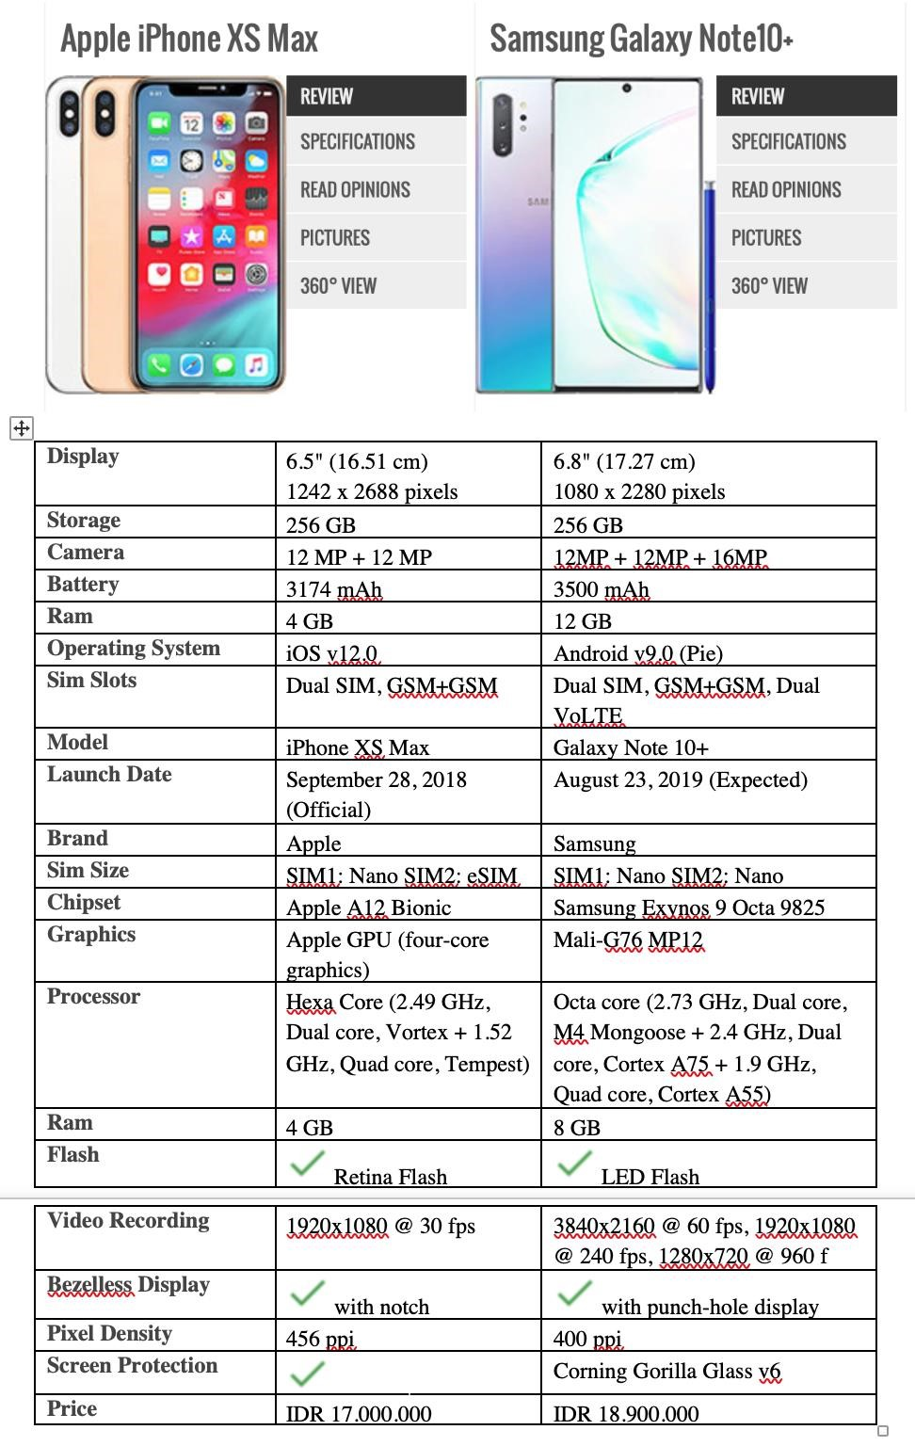

Picture 2.5

**Exercise 16**: In pairs, find two different advertisements of PCs/laptops/any gadgets and write some comparisons (at least 10 sentences) based on their specifications and present it in the class. Use the phrases that you have learned today.

**Look at the example below.**

**Example of Writing a Comparison between Two Things**

1. Samsung Galaxy Note 10+’s size is bigger than iPhone XS Max’s.
2. The storage of Samsung Galaxy Note 10+ and iPhone XS Max has the same capacity.
3. The price of Samsung Galaxy Note 10+ is more expensive than iPhone XS Max.
4. The Samsung galaxy note 10+’s battery capacity is bigger than iphone xs max
5. The size ram of iphone is smaller than Samsung
6. The pixel density of iphone is bigger than samsung